DR. RALF HERMANN ENDS CAREER AT LAUDA

Managing Director leaves the company on August 31, 2024

Lauda-Königshofen, August 31, 2024 - LAUDA DR. R. WOBSER GMBH & CO. KG announces that Dr. Ralf Hermann, Managing Director and Chief Sales Officer (CSO), will leave the company on August 31, 2024. Dr. Hermann looks back on a successful career at LAUDA, during which he has made a significant contribution to the growth and strategic realignment of the world market leader for temperature control units and systems.

Dr. Hermann joined the company in June 2017 as General Manager Constant Temperature Equipment. On February 1, 2018, he was appointed Authorized Signatory and on April 1, 2022, he was finally appointed Managing Director as part of the Drive250 strategy project. In his role as CSO, he was responsible for all of the company's customer-oriented activities, including international sales, key account management, project management in plant engineering, service and product management. He played a key role in the development and implementation of the Drive250 strategy, successfully introduced a new CRM system and further expanded the digitalization of sales.

“It was a pleasure to play an active role in shaping the success story of LAUDA. Together, we were able to increase sales by more than two thirds between 2017 and 2022 despite the difficult COVID years,” explains Dr. Hermann. He has particularly positive memories of working together at LAUDA: “I will always have fond memories of the good cooperation with all my colleagues, especially with our outstanding global sales team.”

Dr. Gunther Wobser, President and CEO of LAUDA, paid tribute to Dr. Hermann's achievements: “We are very grateful to Dr. Hermann for his work and commitment over the past years. His expertise and commitment have been important to the success of LAUDA.”

Following Dr. Hermann's departure, Dr. Gunther Wobser will take over the sales department and will continue to be supported by the two managing directors Dr. Mario Englert (CFO) and Dr. Marc Stricker (COO). LAUDA would like to thank Dr. Ralf Hermann for his commitment and wishes him all the best for the future. The family-owned company is confident that it will be able to continue its growth path in the future and expand its position as world market leader.

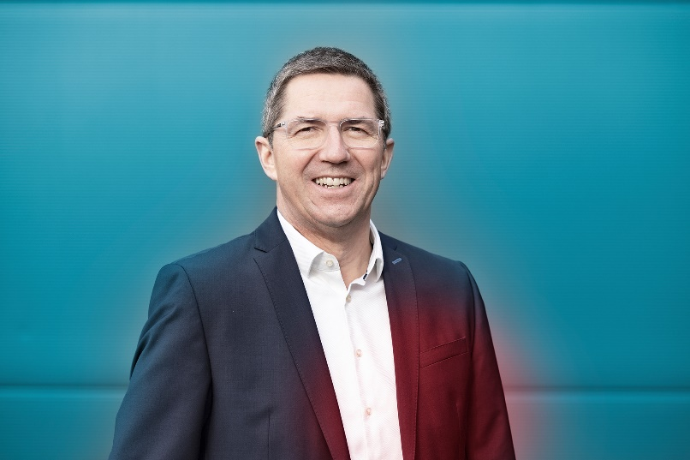

Fig.: The previous Managing Director Dr. Ralf Hermann will be leaving LAUDA on 31.08.2024 © Christoph Weiß

We are LAUDA – the world leader in precise temperature control. Our constant temperature equipment and systems are at the heart of important applications, contributing to a better future. As a complete one-stop supplier, we guarantee the optimum temperature in research, production and quality control. We are the reliable partner for electromobility, hydrogen, chemicals, pharmaceuticals/biotech, semiconductors and medical technology. We have been inspiring our customers for almost 70 years with our expert mentoring and innovative solutions – every day anew and all over the world.

In our company, we always go one step further. We support our employees’ development and are constantly developing ourselves: to create a better future together.

Press contact
We are more than happy to make prepared information about our company, the LAUDA Factory Gallery and our projects in the area of innovation promotion, digitalization and idea management available to the press. We look forward to hearing from you – just give us a call!

CHRISTOPH MUHR
Director Corporate Communications
T + 49 (0) 9343 503-349
christoph.muhr@lauda.de

LAUDA DR. R. WOBSER GMBH & CO. KG, Laudaplatz 1, 97922 Lauda-Königshofen, Deutschland/Germany. Limited partnership: Headquarters Lauda-Königshofen, Registration court Mannheim HRA 560069. General partner: LAUDA DR. R. WOBSER Verwaltungs-GmbH, Headquarters Lauda-Königshofen, Registration court Mannheim HRB 560226. Managing Directors: Dr. Gunther Wobser (President & CEO), Dr. Mario Englert (CFO), Dr. Ralf Hermann (CSO), Dr. Marc Stricker (COO)

