A LIFE CHARACTERIZED BY ENTREPRENEURSHIP

Dr. Gerhard Wobser celebrates his 85th birthday

Lauda-Königshofen, August 26, 2024 – Dr. Gerhard Wobser, long-time President and CEO and formative head of the temperature control specialist LAUDA DR. R. WOBSER GMBH & CO. KG, is celebrating his 85th birthday. The Doctor of Physics, who has led the family business for almost four decades, can look back on a life full of innovations, entrepreneurial challenges and social commitment.

In 1971, Dr. Wobser joined the company founded by his father and, after his father's death in 1977, took over the management of the company together with his brother Karlheinz. Under his aegis, LAUDA developed into a global technology leader for temperature control units and systems.

Dr. Gunther Wobser, President and CEO in the third generation since 2003, pays tribute to his father's life's work: “My father's calm leadership and expertise have made LAUDA what it is today. His ability to combine scientific precision with entrepreneurial flair was and is the basis of our long-term success.”

Even after retiring from active management in 2010, Dr. Gerhard Wobser has remained closely associated with the company as a shareholder and member of the Advisory Board. “We are delighted that we, as the management team, can still benefit from his experience and opinions today,” emphasizes Dr. Gunther Wobser.

In addition to his entrepreneurial activities, Dr. Gerhard Wobser has always distinguished himself through his cultural and social activities. From 1998 until his retirement, he was Chairman of the industry association Spectaris for twelve years and is now its Honorary Chairman. The LAUDA FabrikGalerie, which he founded in 1995, has become an integral part in the regional art scene. From 2013 to 2019, he was Chairman of the Lauda-Königshofen Community Foundation, which he was instrumental in founding. Thanks to his donation, the Kilian Fountain at the Catholic Church in Lauda was put back into operation in 2020.

“My father's achievements go far beyond business,” explains Dr. Gunther Wobser. “His passion for art and culture and his commitment to the community have left a lasting mark not only on Lauda-Königshofen, but on the entire region.”

Dr. Gerhard Wobser has received several awards for his services, including the Staufer Medal (2006), the Federal Cross of Merit on Ribbon (2011) and the Citizen’s Medal of the City of Lauda-Königshofen (2019). Even in retirement, Dr. Wobser remains active. He devotes himself intensively to his cultural interests, attends art exhibitions and concerts and is a passionate golfer.

The birthday celebration will take place in Weimar, the city of Goethe, one of his favorite places. All employees as well as the shareholders and the LAUDA Seniors' Club wish Dr. Gerhard Wobser all the best for his 85th birthday, good health and thank him for his lifelong commitment far beyond the boundaries of the company.

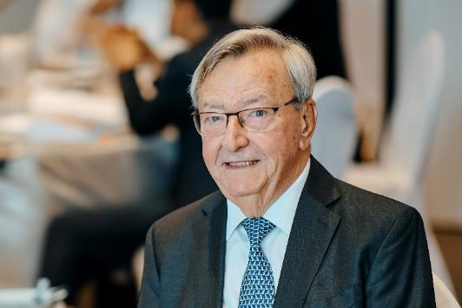

Fig.: Dr. Gerhard Wobser, long-time President and CEO of LAUDA and patron of the arts and culture in the region, celebrates his 85th birthday on 26 August. The Doctor of Physics shaped the development of the temperature control specialist for over four decades. © Chris Rausch

We are LAUDA – the world leader in precise temperature control. Our constant temperature equipment and systems are at the heart of important applications, contributing to a better future. As a complete one-stop supplier, we guarantee the optimum temperature in research, production and quality control. We are the reliable partner for electromobility, hydrogen, chemicals, pharmaceuticals/biotech, semiconductors and medical technology. We have been inspiring our customers for almost 70 years with our expert mentoring and innovative solutions – every day anew and all over the world.

In our company, we always go one step further. We support our employees’ development and are constantly developing ourselves: to create a better future together.

Press contact
We are more than happy to make prepared information about our company, the LAUDA Factory Gallery and our projects in the area of innovation promotion, digitalization and idea management available to the press. We look forward to hearing from you – just give us a call!

CHRISTOPH MUHR
Director Corporate Communications
T + 49 (0) 9343 503-349
christoph.muhr@lauda.de

LAUDA DR. R. WOBSER GMBH & CO. KG, Laudaplatz 1, 97922 Lauda-Königshofen, Deutschland/Germany. Limited partnership: Headquarters Lauda-Königshofen, Registration court Mannheim HRA 560069. General partner: LAUDA DR. R. WOBSER Verwaltungs-GmbH, Headquarters Lauda-Königshofen, Registration court Mannheim HRB 560226. Managing Directors: Dr. Gunther Wobser (President & CEO), Dr. Mario Englert (CFO), Dr. Ralf Hermann (CSO), Dr. Marc Stricker (COO)

