LAUDA EXPANDS ITS ASIAN PRESENCE

New office in Singapore an important milestone for further growth

Lauda-Königshofen, February 2nd, 2024 – LAUDA Singapore PTE. LTD., a subsidiary of the world market leader in precise temperature control, LAUDA DR. R. WOBSER GMBH & CO. KG, celebrated the opening of its new office in Singapore at the end of last year. The event was attended by LAUDA President & CEO Dr. Gunther Wobser and CSO Dr. Ralf Hermann, who is responsible for sales, product management and service, as well as high-ranking guests including the Executive Director of the Singaporean-German Chamber of Commerce, Dr. Tim Philippi.

Dr. Wobser’s welcoming address ran the gamut from the origins of the company as a regional holding in 2007 and its conversion into a sales company in 2015, all the way through to its latest achievements and exciting vision for the promising region. LAUDA Singapore has been certified in accordance with ISO 14001 since July 1st, 2022 and has achieved major successes in Singapore, the ASEAN states, South Korea and Taiwan. “The opening of the new office is an important milestone for the team at LAUDA Singapore and demonstrates LAUDA’s strategy of offering its customers high-quality products and services directly on site,” added Dr. Gunther Wobser. He thanked everyone who contributed to the impressive new site and wished the team every success.

Teck Chia Lee, Managing Director of LAUDA Singapore, is delighted by the opportunities provided by the site, which will drive the growth of the company in the region. The new office at the German Center in Singapore encompasses more than 200 square meters and is characterized by bright, modern architecture. In addition to the sales and service teams, the head office of LAUDA Singapore includes a training center and state-of-the-art service workshop.

“With the new site, LAUDA Singapore is now prepared for the next successful step in the Drive250 strategy. The entire team is proud to be part of the LAUDA Group, which has offered innovative and reliable temperature control solutions for almost 70 years,” said Teck Chia Lee, in thanks for the trust that has been placed in the company.
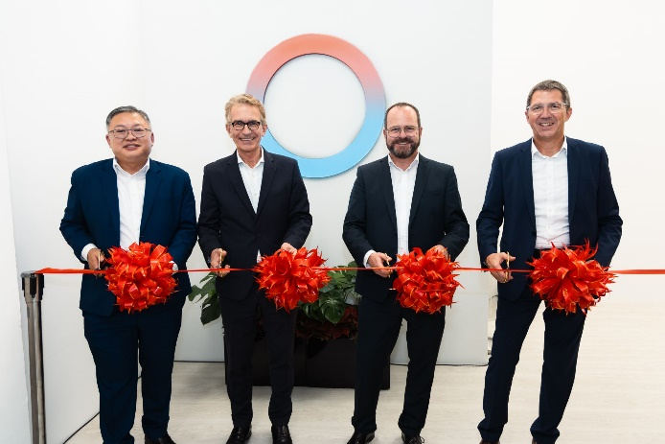
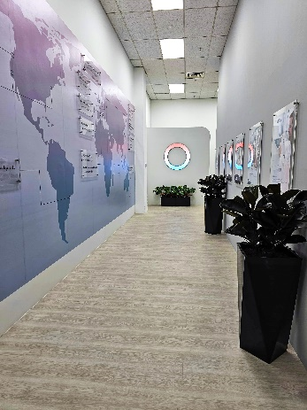
Fig. 1: From left to right: Managing Director of LAUDA Singapore Teck Chia Lee, Executive Director of the Singaporean-German Chamber of Commerce Dr. Tim Philippi, LAUDA President & CEO Dr. Gunther Wobser and LAUDA CSO Dr. Ralf Hermann. © LAUDA
Fig. 2: The new office
in Singapore is characterized by bright, modern architecture.
© LAUDA

We are LAUDA – the world leader in precise temperature control. Our constant temperature equipment and systems are at the heart of important applications, contributing to a better future. As a complete one-stop supplier, we guarantee the optimum temperature in research, production and quality control. We are the reliable partner for electromobility, hydrogen, chemicals, pharmaceuticals/biotech, semiconductors and medical technology. We have been inspiring our customers for almost 70 years with our expert mentoring and innovative solutions – every day anew and all over the world.

In our company, we always go one step further. We support our employees’ development and are constantly developing ourselves: to create a better future together.

Press contact
We are more than happy to make prepared information about our company, the LAUDA Factory Gallery and our projects in the area of innovation promotion, digitalization and idea management available to the press. We look forward to hearing from you – just give us a call!

CHRISTOPH MUHR
Head of Corporate Communications
T + 49 (0) 9343 503-349
christoph.muhr@lauda.de

LAUDA DR. R. WOBSER GMBH & CO. KG, Laudaplatz 1, 97922 Lauda-Königshofen, Deutschland/Germany. Limited partnership: Headquarters Lauda-Königshofen, Registration court Mannheim HRA 560069. General partner: LAUDA DR. R. WOBSER Verwaltungs-GmbH, Headquarters Lauda-Königshofen, Registration court Mannheim HRB 560226. Managing Directors: Dr. Gunther Wobser (President & CEO), Dr. Mario Englert (CFO), Dr. Ralf Hermann (CSO), Dr. Marc Stricker (COO)

