HYDROGEN TO BE A KEY TECHNOLOGY IN EUROPEAN ENERGY TRANSITION

Minister-President Winfried Kretschmann visits LAUDA at the Hanover Messe exhibition grounds

Lauda-Königshofen, April 20th, 2023 – Important visit for LAUDA DR. R. WOBSER GMBH & CO. KG at Hydrogen + Fuel Cells EUROPE exhibition. At Europe’s biggest exhibition for hydrogen, fuel cells, and stationary batteries, which takes place at the Hanover Messe exhibition grounds, the world market leader in precise temperatures was able to welcome Minister-President of Baden-Württemberg, Winfried Kretschmann. LAUDA’s Managing Director for Sales, Dr. Ralf Hermann, personally greeted the Minister-President at the LAUDA booth and explained to him the family company’s temperature control solutions, which have been specially developed for cooling of hydrogen. Efficient, high-performance temperature control technology is needed for electrolysis and the application of liquid hydrogen, one of the key technologies of the energy transition.

“Hydrogen holds great opportunities for medium-sized businesses as part of a nationwide or Europe-wide energy transition strategy,” explains Dr. Ralf Hermann. “Which is why, as a world market leader, we are all the more pleased that our innovative solutions for hydrogen cooling have the interest and backing of the state government.” LAUDA will continue exhibiting its innovative cooling solutions in the hydrogen section of Hydrogen Fuel + Cells EUROPE at Stand B 20 in Hall 13 until April 21st, 2023.

“The increased use of hydrogen is just one of the ways that we can make our economy and society more ecological and sustainable. I am delighted that companies from Baden-Württemberg, such as LAUDA, are contributing to the success of this transformation. Temperature control for hydrogen is one of many fields that play an important role in this area,” said Minister-President Kretschmann.

LAUDA offers precise cooling for hydrogen applications
Temperature control solutions for the cooling of hydrogen are especially utilized for the cooling of electrolyzers in the manufacture of green hydrogen. Likewise, they are also used where hydrogen is used and supplied, i.e. at hydrogen filling stations and in compression cooling. Refueling of heavy vehicles, such as trains or ships, uses liquid hydrogen, which must be heavily compressed. This results in high technical requirements for the systems involved in transport, storage and the actual refueling process. For this purpose, LAUDA offers innovative constant temperature equipment that meet both the particular requirements of hydrogen as an energy source, as well as external factors when refueling.

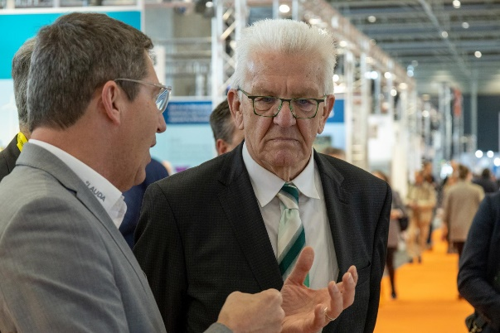Fig. 1: Managing Director of LAUDA, Dr. Ralf Hermann, (left) in conversation with the Minister-President of Baden-Württemberg, Winfried Kretschmann © LAUDA/Robert Horn | 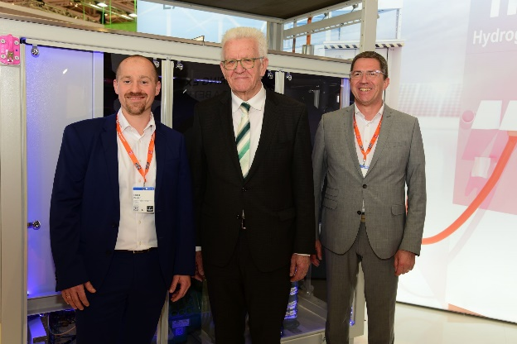  Fig. 2: Minister-president of Baden-Württemberg, Winfried Kretschmann, together with the Head of Product Management, Enrico Bossart (left), and the Managing Director of LAUDA, Dr. Ralf Hermann (right © State Ministry of Baden-Württemberg

We are LAUDA – the world leader in precise temperature control. Our constant temperature equipment and systems are at the heart of important applications, contributing to a better future. As a complete one-stop supplier, we guarantee the optimum temperature in research, production and quality control. We are the reliable partner for electromobility, hydrogen, chemicals, pharmaceuticals/biotech, semiconductors and medical technology. We have been inspiring our customers for more than 65 years with our expert mentoring and innovative solutions – every day anew and all over the world.

In our company, we always go one step further. We support our employees’ development and are constantly developing ourselves: to create a better future together.

Press contact
We are more than happy to make prepared information about our company, the LAUDA Factory Gallery and our projects in the area of innovation promotion, digitalization and idea management available to the press. We look forward to hearing from you – just give us a call!

CLAUDIA HAEVERNICK
Head of Corporate Communication
T + 49 (0) 9343 503-349
claudia.haevernick@lauda.de

LAUDA DR. R. WOBSER GMBH & CO. KG, Laudaplatz 1, 97922 Lauda-Königshofen, Deutschland/Germany. Limited partnership: Headquarters Lauda-Königshofen, Registration court Mannheim HRA 560069. General partner: LAUDA DR. R. WOBSER Verwaltungs-GmbH, Headquarters Lauda-Königshofen, Registration court Mannheim HRB 560226. Managing Directors: Dr. Gunther Wobser (President & CEO), Dr. Mario Englert (CFO), Dr. Ralf Hermann (CSO), Dr. Marc Stricker (COO)

