LAUDA CARSHARING GOES LIVE

How the world market leader is addressing the issue of sustainability with its fleet of company cars

Lauda-Königshofen, 23 January 2023 – After around one and a half years of intensive work and development, the LAUDA Carsharing Service is now live and can also be used by external members of the public. LAUDA DR. R. WOBSER GMBH & CO. KG, the world leader in precise temperature control, is therefore playing a pioneering role in the region and making its entire fleet of company cars available to the public depending on availability. Following the initial idea of the President & CEO, Dr. Gunther Wobser, who initiated the project after the first important discussions and played a significant role in driving it forward, the LAUDA Carsharing Team headed by his Managing Director colleague Dr. Mario Englert has been working continuously on its implementation over the past few months.

For the company, sustainability means scrutinising and questioning every action and every process: What could be improved, what adjustments could be made? Smaller projects or changes can sometimes add up to make a big difference. For a family-owned company like LAUDA, the passing on of values and the prudent use of raw materials naturally play a significant role: "Our innovative constant temperature equipment and systems save a great deal of energy every day and are extremely durable. As a company, we have been certified to the ISO 14001 environmental management system since 2022. As a model company, we aim to be completely climate-neutral as early as 2030", says Dr. Gunther Wobser. “In addition to the economical use of resources, existing equipment must be used in the best way possible. So I had the idea of making our high-quality company cars, which just stand around on the premises in the evenings and at weekends, available to the general public as our city's first carsharing service. We implemented the idea together with my colleague Dr. Englert and a motivated team, and are now going live."

Using the carsharing service is simple: Everything is done via smartphone after downloading the evemo app. This allows you to rent, unlock, lock and return the car. Customers are registered and cars booked via this link or QR code: https://lauda.evemo.app/login

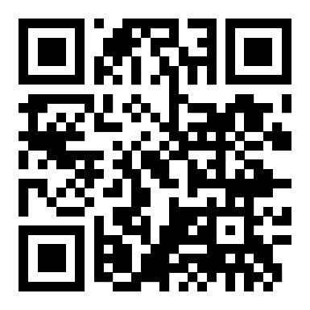 | LAUDA CARSHARING  LAUDA Carsharing enables customers to rent a LAUDA Carsharing vehicle at the Lauda-Königshofen location directly via the evemo app. Contact by email: carsharing@lauda.de  The evemo app provides renters with a clear overview of the available vehicles and enables them to easily lock and unlock the cars they have booked via the app on their smartphone. The current odometer reading is also reported to the app directly from the car. evemo will be available for external customers on a daily basis between 7:00 and 22:00 via a service hotline (+49 6131 83 832 336).

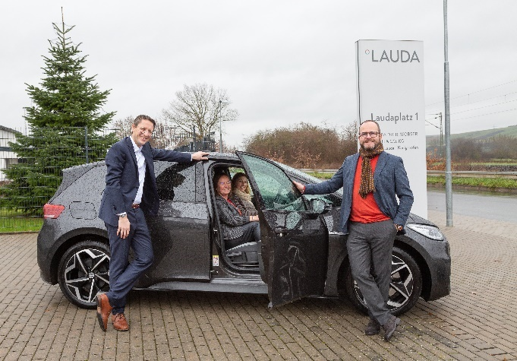  Dr. Mario Englert (left) and Dr. Gunther Wobser with the LAUDA Carsharing Team  © Jürgen Besserer | 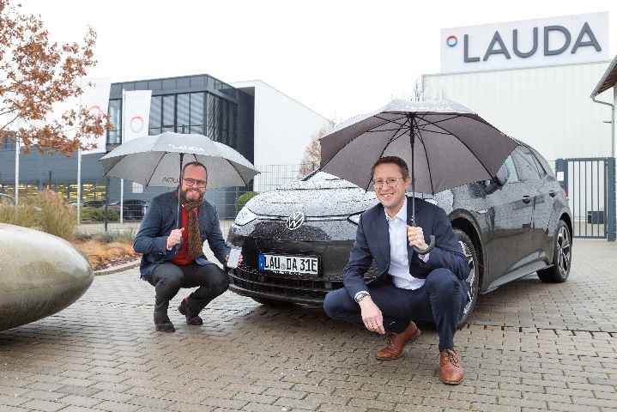  LAUDA Carsharing initiator Dr. Gunther Wobser (left) and Dr. Mario Englert  © Jürgen Besserer

We are LAUDA – the world leader in precise temperature control. Our constant temperature equipment and systems are at the heart of important applications, contributing to a better future. As a complete one-stop supplier, we guarantee the optimum temperature in research, production and quality control. We are the reliable partner for electromobility, hydrogen, chemicals, pharmaceuticals/biotech, semiconductors and medical technology. We have been inspiring our customers for more than 65 years with our expert mentoring and innovative solutions – every day anew and all over the world.

In our company, we always go one step further. We support our employees’ development and are constantly developing ourselves: to create a better future together.

Press contact
We are more than happy to provide the press with prepared information about our company and especially about our projects on the issues of environmental protection and sustainability. We will be pleased to arrange interviews with our management about these issues. We look forward to hearing from you – just give us a call!

CLAUDIA HAEVERNICK
Head of Corporate Communication
T + 49 (0) 9343 503-349
claudia.haevernick@lauda.de

